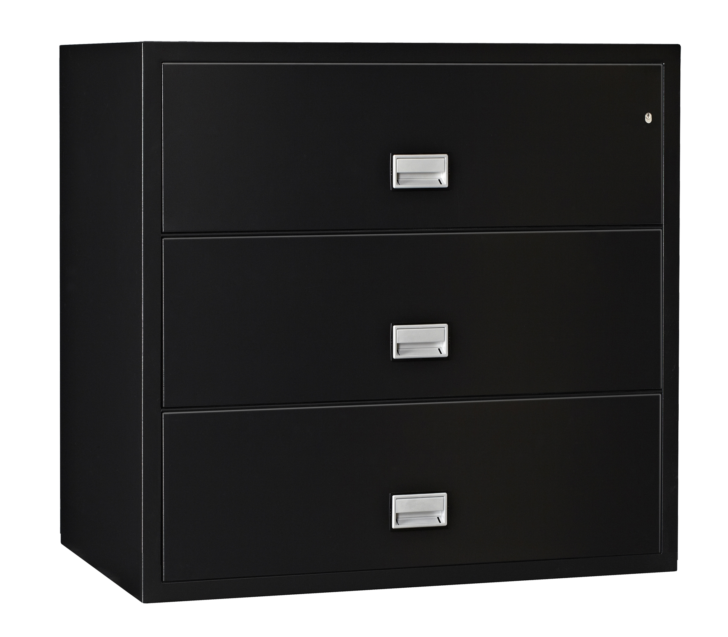
Phoenix World Class Lateral File Specifications

Fire Resistance & Impact Rating
These files carry the prestigious SP classification NT Fire 017 60 Paper which includes a one-hour fire test at 1700°F and a 2000°F explosion test. It has also been tested and certified for impact resistance during a 30’ fall in compliance with KIS standards. The file’s certification is considered equal to the UL Class 350 -1 Hr. Fire & Impact resistance classification.
MTC Grade B Rating
This file now carries the prestigious MTC Grade B – 30 minute rating, certifying that certain types of less sensitive computer media (such as CDs, DVDs, USBs, flash drives, and memory sticks) can be safely stored inside.

Insulation
Phoenix’s proprietary insulation is asbestos-free, and uses modern age chemistry principles to provide outstanding fire protection. Insulation between each drawer makes each drawer a separate insulated container.

Inner Steel Jacket
Insulation is fully encased between an inner and outer steel wall, keeping it out of contact with documents and out of the file suspension and locking mechanism.

File Body
File body is made using .20 gauge steel in a uni-body construction to provide an elegant look while providing optimal structural strength.

Drawer Pulls
Attractive, sturdy, recessed metal drawer pulls contain easy-to-read label holders.

Drawer Suspensions
Phoenix uses a unique three-way suspension that is securely mounted to the file body and safely supports the drawer from both the sides and from underneath when open and fully loaded.

Drawer Bodies
Each drawer body has high sides and cross bars for use with hanging folders.

Drawer Heads
Drawer heads are made of welded steel and are insulated with our proprietary insulation. Each drawer head interlocks with the file body to make drawers resistant to heat transfer using a labyrinth sealing system. Special gaskets prevent water damage caused by fire hose spray or sprinklers.

Locks
Phoenix files use a standard plunger lock that when engaged locks all drawers.

Lock Bypass
Each file drawer is equipped with a lock bypass mechanism that enables the file user to allow a drawer to remain unlocked and accessible even when the file is locked.

Anti-Tip Mechanism

As a special safety feature, each drawer is equipped with a special anti-tip mechanism that prevents more than one drawer open at a time.

Finish
Phoenix World Class files are painted with an extremely durable water-based, air-dry, textured enamel paint finish.

Colors
Phoenix World Class insulated files are available in black and putty colors.

Product Warranty
All Phoenix files carry a three-year parts and labor warranty.

Free After A Fire Replacement
If your Phoenix fire file is exposed to a fire, Phoenix will replace the file free!

Phoenix Safe International LLC

PO Box 608
Lebanon, IN 46052-0608
800-636-0778
Fax 765-483-0962
www.phoenixsafeusa.com

Dimensions
Overall Cabinet: 41 ¾" H x 31” W x 23 5/8" D
Inside Drawer: 10 ½” H x 25” W x 15" D
Weight: 500 lbs.
Model LAT3W31
All weights & sizes are approximate. Phoenix policy is one of constant improvement. We therefore reserve the right to alter any part of the specification achieved in this publication without notice
1/12/12




